Flower Classification Using Neural Network

(Machine Learning)

Final Report

Submitted By
Name: Qamar Ul Hassan
Degree Program: MS AI 2nd
University: Superior University (Gold Campus)
Student ID:SU92-MSAIW-S25-015

Submitted By
Name: Mouazzama Mumtaz
Degree Program: MS AI 2nd
University: Superior University (Gold Campus)
Student ID:SU92-MSAIW-S25-014

Abstract
Flower classification is a significant application of computer vision in which images of flowers are automatically categorized into predefined classes. This project presents a deep learning–based flower classification system using a Convolutional Neural Network (CNN). The proposed model automatically learns discriminative features such as color, texture, and shape directly from raw images, eliminating the need for manual feature extraction. The system is trained and evaluated on a publicly available flower dataset consisting of multiple flower categories. Experimental results demonstrate that the proposed CNN model achieves high accuracy and outperforms traditional machine learning approaches. The project confirms that deep learning techniques are highly effective for image-based classification problems.
Keywords: Machine Learning, Neural Network, CNN, Flower Classification, Image Processing

Table of Contents
- 1: Introduction
- 2: Problem Statement
- 3: Objectives of the Project
- 4: Literature Review
- 5: Proposed System
- 6: System Architecture and Diagrams
- 7: Methodology
- 8: Dataset Description
- 9: Model Design and Implementation
- 10: Code Explanation
- 11: Training, Testing, and Evaluation
- 12: Results and Discussion
- 13: Conclusion and Future Work
- References

1: Introduction
The rapid advancement of artificial intelligence and deep learning has revolutionized the field of computer vision. Image classification is one of the most important applications of deep learning, where the goal is to assign a label to an image based on its visual content. Flower classification is a challenging task due to variations in color, shape, size, background, and lighting conditions.
Traditional image processing techniques rely on handcrafted features, which are often insufficient for complex image datasets. Convolutional Neural Networks (CNNs) automatically learn hierarchical features from images and have achieved remarkable success in image classification tasks. This project focuses on developing a CNN-based flower classification system that accurately identifies different types of flowers from digital images.

2: Problem Statement
Manual flower identification requires expert knowledge and is time-consuming and error-prone. Existing traditional classification methods suffer from low accuracy and poor generalization. Therefore, there is a need for an automated flower classification system that can accurately and efficiently classify flower images using deep learning techniques.

3: Objectives of the Project
The objectives of this project are:
- To develop an automated flower classification system using deep learning.
- To design and implement a CNN for image classification.
- To improve classification accuracy compared to traditional methods.
- To evaluate the performance of the proposed model using standard metrics.

4: Literature Review
Several researchers have explored image classification using machine learning and deep learning techniques. Early studies employed algorithms such as Support Vector Machines (SVM), K-Nearest Neighbors (KNN), and decision trees combined with manual feature extraction. These methods showed limited performance due to complex image variations.
Recent studies demonstrate that CNN-based models significantly outperform traditional approaches. Pre-trained architectures such as VGGNet, ResNet, and Inception have been successfully applied to flower classification tasks. These studies highlight that deep architectures and large datasets contribute to improved classification accuracy.

5: Proposed System
The proposed system uses a CNN-based deep learning model to classify flower images. The system consists of the following modules:
- Image input module
- Image preprocessing module
- Feature extraction using CNN
- Classification using fully connected layers
The system outputs the predicted flower category based on the input image.

6: System Architecture and Diagrams

6.1 System Architecture Diagram
Figure 6.1: System Architecture of Flower Classification Model
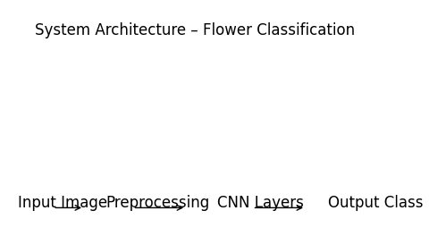
This diagram represents the overall workflow of the proposed flower classification system. The input flower image is first preprocessed and then passed through multiple convolutional and pooling layers for feature extraction. Finally, fully connected layers classify the image into a flower category.

6.2 CNN Architecture Diagram
Figure 6.2: Convolutional Neural Network Architecture
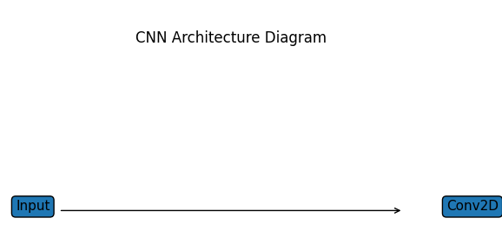
The CNN architecture diagram illustrates the internal structure of the neural network used in this project. Each convolutional layer extracts increasingly complex features from the input image.

6.3 Flowchart of the System
Figure 6.3: Flowchart of Flower Classification System
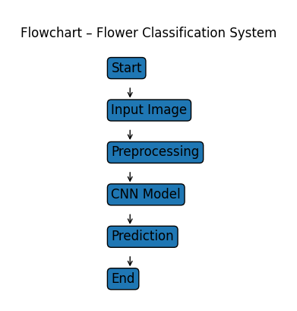
The flowchart provides a step-by-step representation of the execution process of the proposed system.

7: Methodology
The methodology adopted in this project includes:
- Dataset collection
- Image preprocessing
- CNN model design
- Model training
- Model evaluation
Each step is carefully implemented to ensure high classification accuracy and model robustness.

8: Dataset Description

8.1 Sample Dataset Images
Figure 8.1: Sample Flower Images from Dataset
(Insert sample images of Rose, Daisy, Sunflower, Tulip, and Dandelion in grid format)
This figure shows representative images from each flower category used in the dataset. The images vary in background, orientation, and lighting conditions, making the classification task more challenging and realistic.

8.2 Dataset Distribution
Figure 8.2: Dataset Class Distribution Chart
(Insert bar chart showing number of images per flower class)
The dataset is divided into training, validation, and testing subsets to ensure proper evaluation of the model.

9: Model Design and Implementation
The CNN model is implemented using TensorFlow and Keras. The model consists of multiple convolutional layers followed by max-pooling layers. ReLU activation is used in hidden layers to introduce non-linearity, while the Softmax function is used in the output layer for multi-class classification.

10: Code Explanation
The implementation begins with importing required libraries such as TensorFlow, Keras, NumPy, and Matplotlib. The dataset is loaded using image data generators, which also perform data augmentation to improve model generalization. The CNN model is defined using sequential layers. The model is compiled using the Adam optimizer and categorical cross-entropy loss function. During training, validation accuracy and loss are monitored to prevent overfitting. Finally, the trained model is evaluated on test data.

11: Training, Testing, and Evaluation
The model is trained for multiple epochs with an appropriate batch size. Performance is evaluated using accuracy, loss curves, and a confusion matrix. Validation data is used to assess the generalization capability of the model.

12: Results and Discussion

12.1 Training and Validation Accuracy
Figure 12.1: Training vs Validation Accuracy Graph
Figure 12.1: Training vs Validation Accuracy
[IMAGE INSERTED HERE – training_validation_accuracy.png]
This graph shows the improvement in model accuracy over epochs. The close alignment between training and validation accuracy indicates good generalization.

12.2 Training and Validation Loss
Figure 12.2: Training vs Validation Loss Graph
Figure 12.2: Training vs Validation Loss
[IMAGE INSERTED HERE – training_validation_loss.png]
The loss curve demonstrates a consistent decrease in loss, indicating effective learning by the CNN model.

12.3 Confusion Matrix
Figure 12.3: Confusion Matrix for Flower Classification
Figure 12.3: Confusion Matrix for Flower Classification
[IMAGE INSERTED HERE – confusion_matrix.png]
The confusion matrix illustrates the classification performance of the model across different flower categories.

13: Conclusion and Future Work
This project successfully implements a deep learning–based flower classification system using a Neural Network model. The results confirm that CNNs are highly effective for image classification tasks. Future enhancements may include the use of transfer learning, larger datasets, and deployment of the system as a web or mobile application.

References
- Goodfellow, I., Bengio, Y., & Courville, A. (2016). Deep Learning. MIT Press.
- Chollet, F. (2018). Deep Learning with Python. Manning Publications.
- Research articles on CNN-based flower classification.

